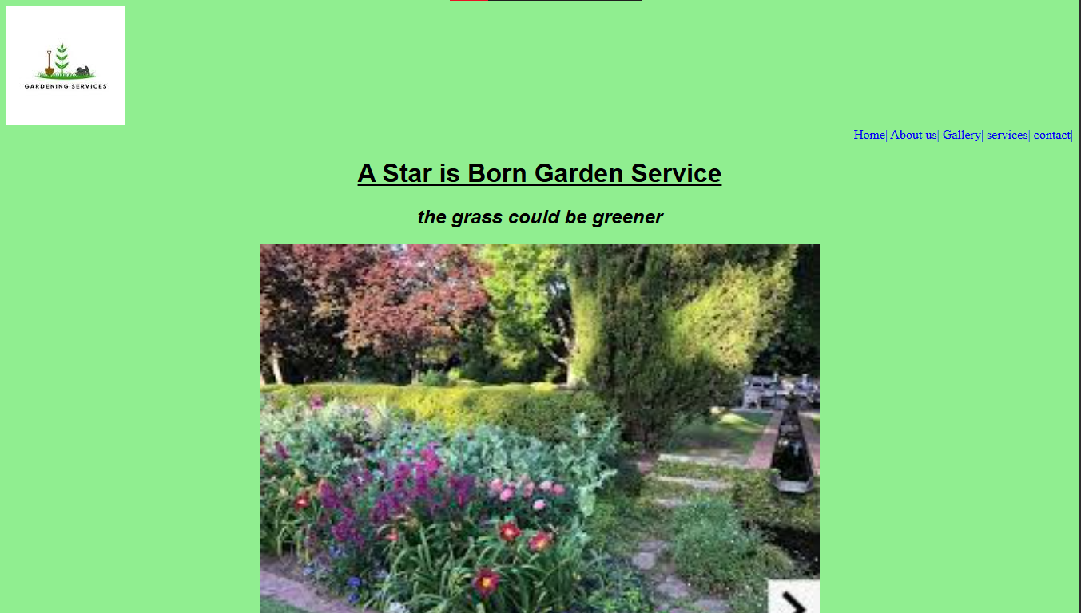
Before
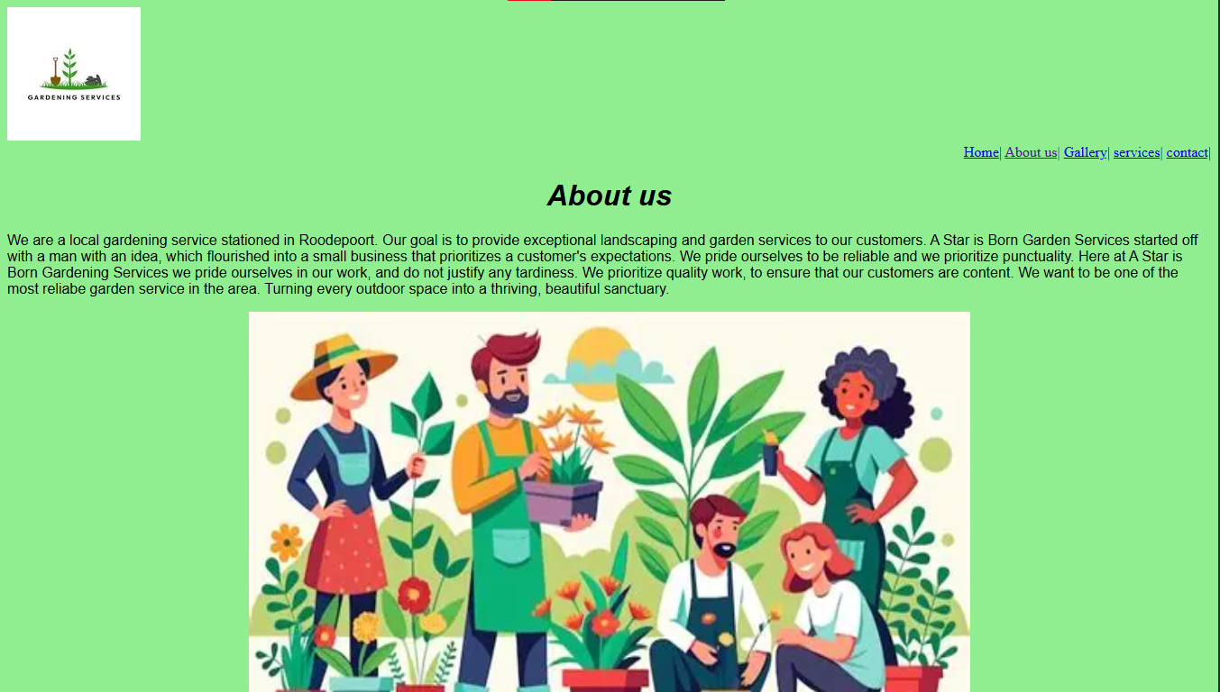

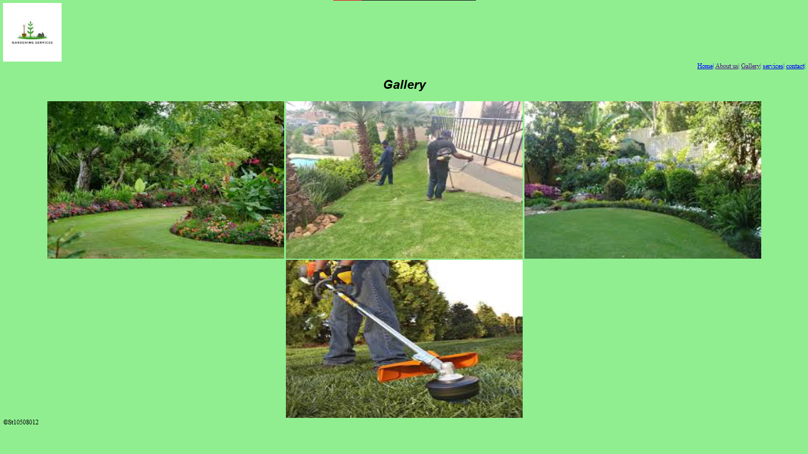

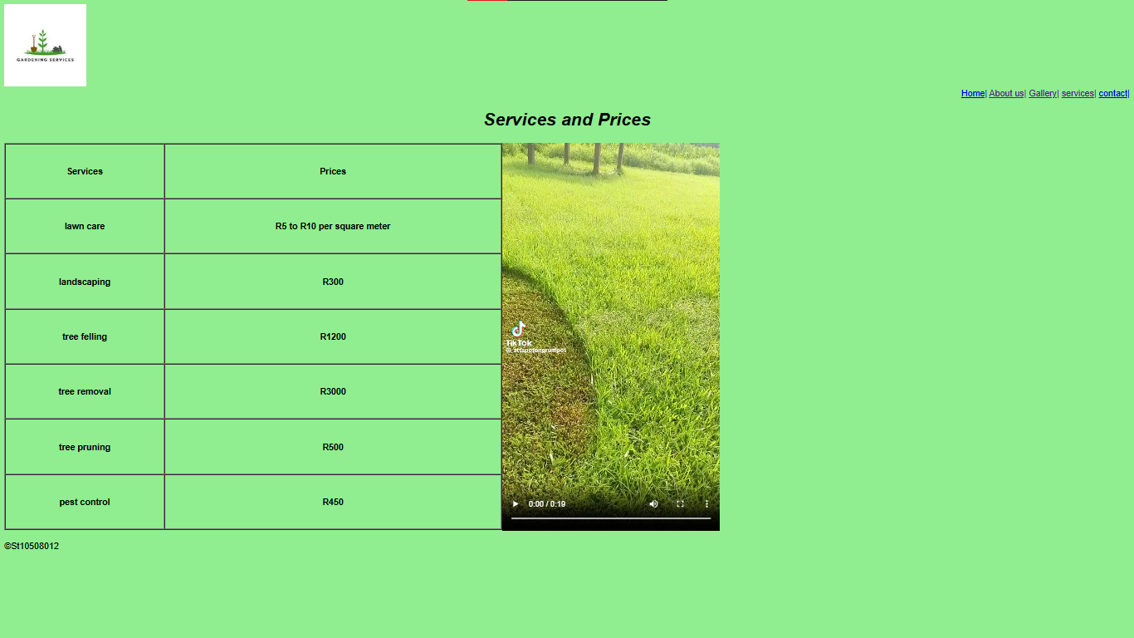

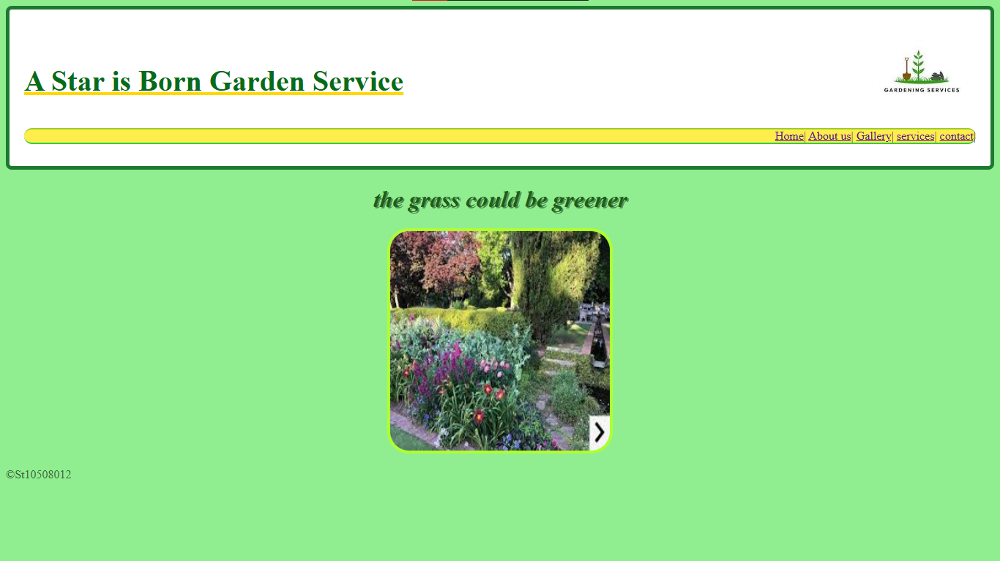
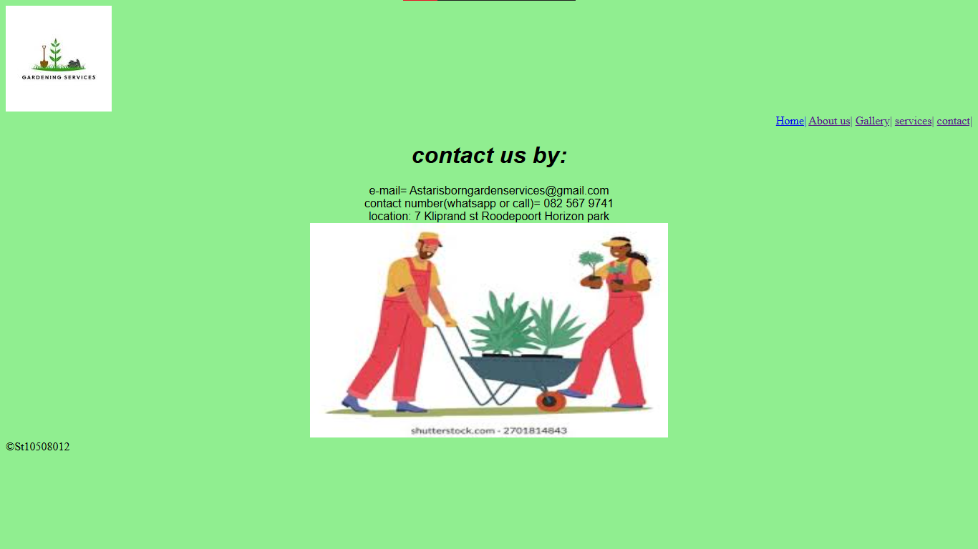
After
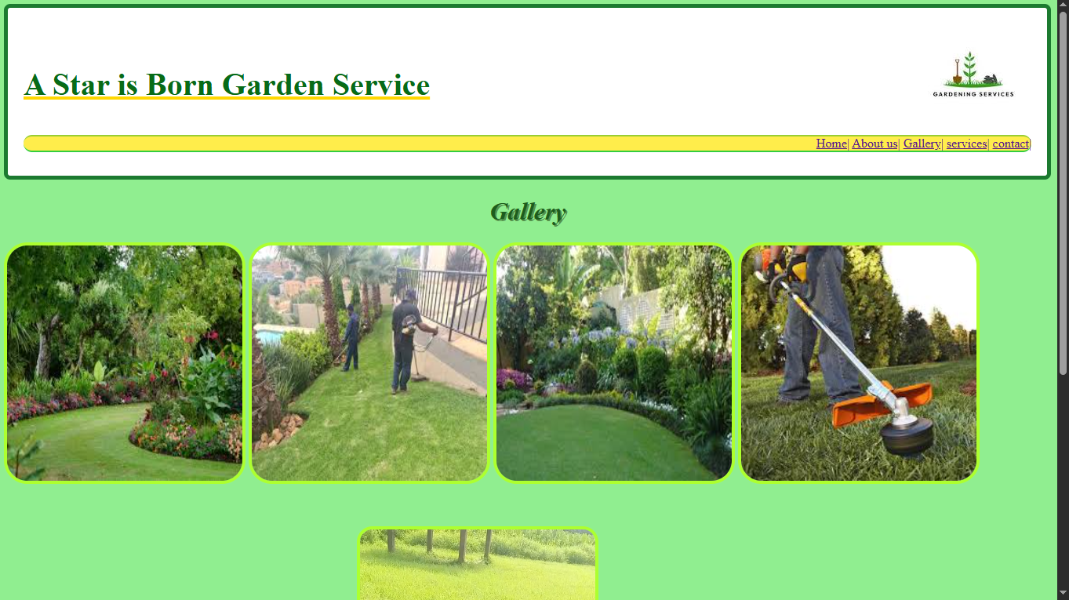
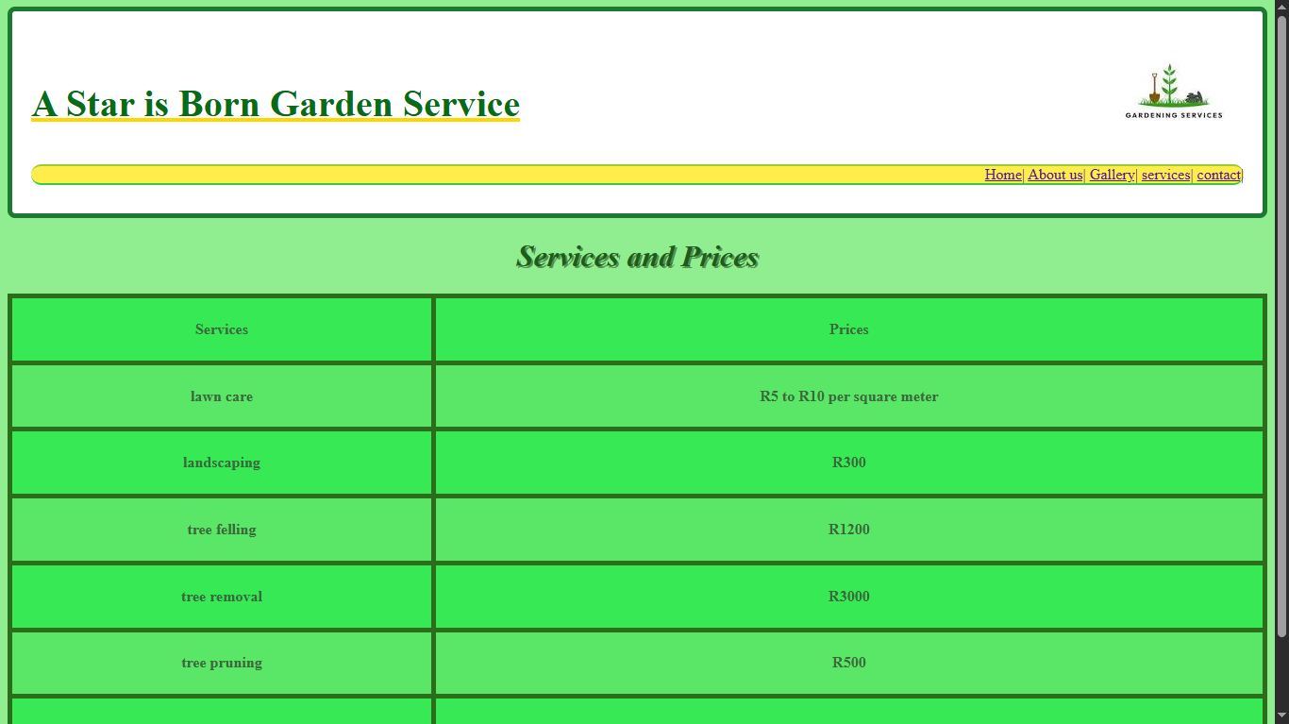
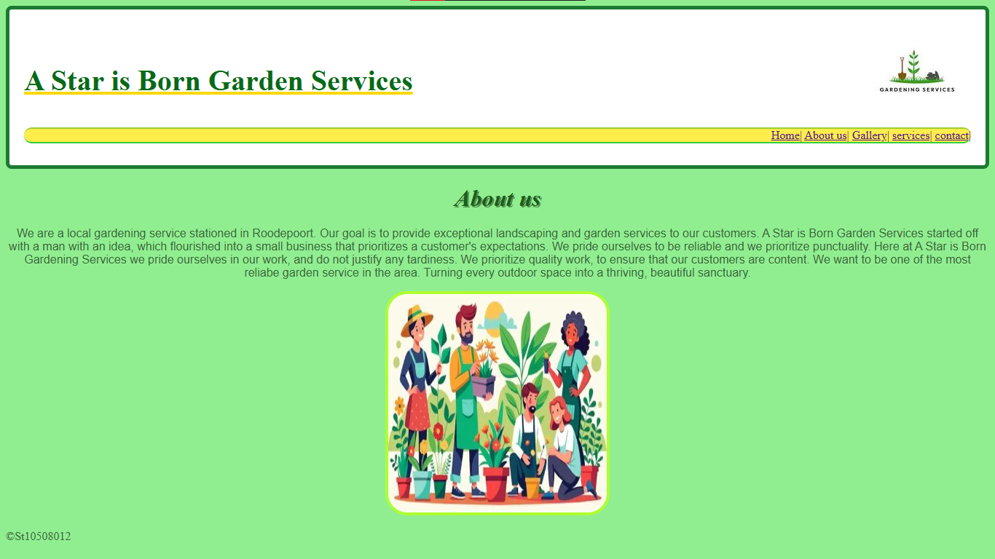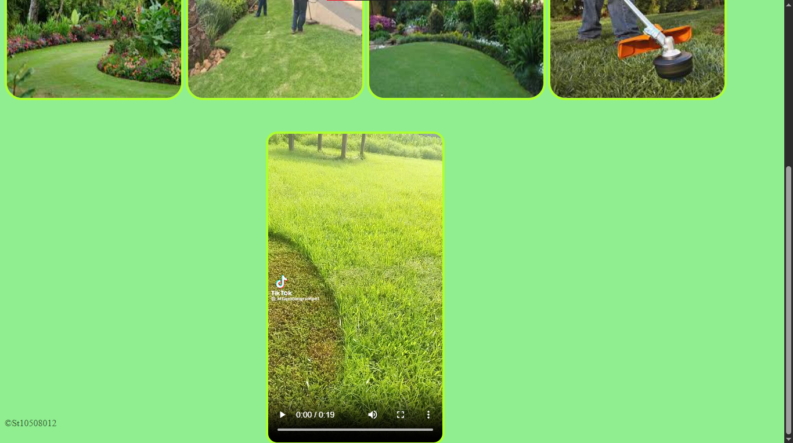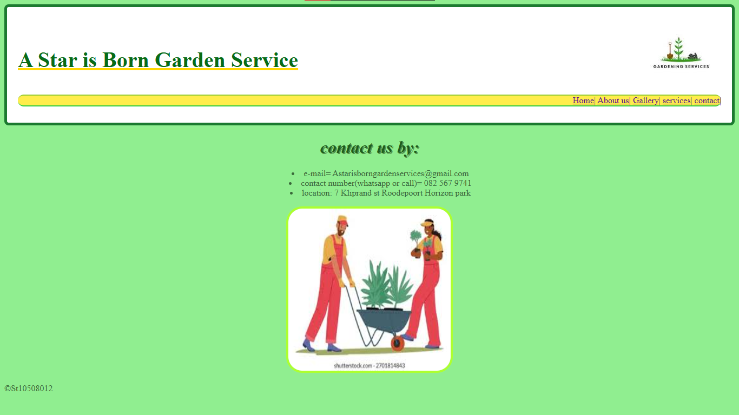

Explanation of my changes
I used external CSS to create borders around my images, and made them rounded. I also moved the video that was originally on the services webpage to the gallery webpage. The video also got rounded corners and a border. I made the header a different colour (white) ,and I made the navigation bar yellow. I placed the organization’s name in the header to ensure that it would be on every webpage. I also changed the colour of the name “A Star is Born Garden Service” to green and underlined with a yellow line. I changed the table on the services webpage so that it would be the width of the webpage and I changed its colours to two different shades of green.

